**Mother.java**

class Mother{

static class Son

{

public void doSomething()

{

System.out.println("\nPLaying games");

}

}

class Daughter

{

public void doSomething()

{

System.out.println("\nSleeping");

}

}

}

**Check.java**

class Check{

public static void main(String[] args)

{

Mother.Son son =new Mother.Son();

son.doSomething();

Mother mother = new Mother();

Mother.Daughter daughter = mother.new Daughter();

daughter.doSomething();

Mother.Daughter daughter2 = new Mother().new Daughter();

daughter2.doSomething();

}

}

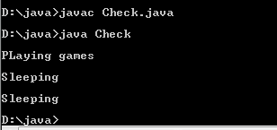

**Anonymous Example**

Flyable.java

class Flyable

{

public void start()

{

System.out.println("Starting");

}

}

**Check.java**

class Check{

public static void main(String[] args)

{

Flyable obj = new Flyable(){

public void start()

{

System.out.println("\nSomething started");

}

};

obj.start();

}

}

